BLET  Town  Hall  WHEN?  WEDNESDAY JUNE 14 2017  0900 AM  WHERE?  DOUBLE TREE HILTON ONTARIO AIRPORT  222 NORTH VINEYARD AVE.  ONTARIO CA   |   ALL BLET MEMBERS ARE INVITED TO ATTEND  COME AND PARTICIPATE IN AN INTERACTIVE DISCUSSION OF CURRENT EVENTS THAT AFFECT YOU!  GUEST SPEAKERS  BLET AND TEAMSTERS RAIL CONFERENCE PRESIDENT DENNIS PIERCE, BLET WESTERN LINES GENERAL CHAIRMAN D.W. “BILL” HANNAH, BNSF GENERAL CHAIRMAN J. ALAN HOLDCRAFT  LUNCH FOLLOWING THE MEETING  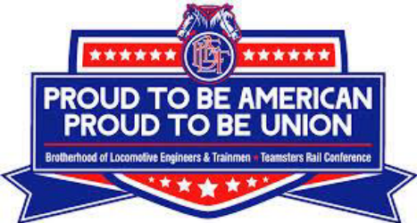  FOR THE COMMITTEE BLET DIVISION 5

